**HUMAN CAPITAL, PHYSICAL CAPITAL, AND ECONOMIC GROWTH NEXUS: A DESCRIPTIVE ANALYSIS**

**Nurgis Bibi**

Ph.D. Scholar Department of Economics, PMAS-AAUR Arid Agriculture University, Rawalpindi

[nurgisbibi06@gmail.com](mailto:nurgisbibi06@gmail.com)

**Saima Akhtar**

Ph.D. Scholar, Department of Economics, PMAS-AAUR Arid Agriculture University, Rawalpindi

[Capri198@hotmail.com](mailto:Capri198@hotmail.com)

**Saima Asad[1]**

Assistant Professor, Department of Economics, PMAS-AAUR Arid Agriculture University, Rawalpindi

[saima.asad@uaar.edu.pk](mailto:arahman@uaar.edu.pk)

**ABSTRACT**

*In formulating policies, no nation can dispute the significance of investing in human capital in attracting physical capital and fostering economic expansion. Economic Growth has a significant link with Physical Resources and Human Capital. The main aim of this study is to examine the relationship between economic growth and both physical and human capital. The study's main objective is to examine how Pakistan's economic growth has been impacted by both people and physical capital. This study attempts to evaluate the connection between Pakistan's total economic growth, human capital, and physical capital using World Bank time series data from 1990 to 2020. To determine the influence of physical capital and human resources on the nation's economic expansion, descriptive statistics are utilized. The significance of both human and physical capital for Pakistan's growth is highlighted by this study. life expectancy influences human capital, gross fixed capital formation influences physical capital. The average life expectancy in Pakistan is 63 years, according to the results. Politically related flux is also revealed by gross fixed capital formation. It increased to 4.9 percent in 2020. Variations were also seen in the GDP growth rate. The pandemic of 2019 causes a reduction in gross fixed capital formation and life expectancy. The policy implications indicate the need for increased gross fixed capital investment. It is also recommended that the government set aside a sizable portion of its budget. In addition, to achieve economic growth, public awareness campaigns about investments in human and physical capital should be conducted.*

**Keywords**: Physical Capital, Human Capital, Economic Growth, Descriptive Analysis, Pakistan

**INTRODUCTION**

According to a study by Hafeez and Rahim from 2019, there is a favorable correlation between gross fixed capital and economic growth. The favorable relationship between human capital and economic growth has been the subject of numerous studies, and research in this field is still ongoing. According to academics, improving labor competencies through education, training, and health can have a satisfactory effect on economic growth. Numerous research, including those carried out in 2019 by Islam and Khan, have shown that the development of human capital favorably affects total economic growth.

Additionally, the assessment of short-run and long-run connections amid human resource and economic growth in Pakistan is also checked. Unlike multivariate techniques are applied to evaluate co-integration amongst variables. Johansen co-integration as well as Augmented Dickey There is a positive relationship between gross fixed capital and economic growth (Hafeez and Rahim, 2019). Numerous researches have examined the positive correlation between economic growth and human capital. According to studies, there is currently a lot of analysis going on between them. Scholars believe that improved labor force abilities and competencies, coupled with training, health, and education, can boost economic growth. Fuller unit root methods are applied in multiple studies. The long- and short-term associations between variables are examined using the error correlation model. The variables that are considered independent include education, child mortality, economic growth, and fixed capital formation. Human resources are a production feature that is further outstretched, and it is heavily funded by both health and education. In addition to health, education has a positive impact on the gross domestic product and increased efficiency. The result shows a long-term relationship between human resource growth and economic growth. Additional aspects are showing imperative effects on gross domestic product. (Sammar and Waqas, 2014). Good governance can promote economic growth in different regions (Zalle, 2019).

**Objectives Of Study**

The following goals guide the design of the current study:

* To assess the association of human capital with GDP Per Capita growth rate in Pakistan.
* To investigate the association of physical capital with GDP Per Capita growth rate in Pakistan.

**REVIEW OF LITERATURE**

Mudassae et al; (2019) studied that the growth of the economy was directly correlated with human resources. The augmented Solow production function best fits the data. For every economy, the rate of population growth and economic growth were inversely correlated.

Ogundari et al; (2018) studied that the development of human capital was crucial to economic expansion. They gathered information from 35 countries in Sub-Saharan Africa. We obtained our data from secondary sources. The two variables used to collect human resources were education and health. When compared to education, health has a greater impact on economic growth. Sarkar et al; (2021) and Ho, (2018) formulated that both in the short and long terms, human resources have a positive impact on economic growth. They concluded that governments ought to enact measures that will spur economic expansion as a result of the expansion of human resources.Ruhma Khan and Imran Chaudhary (2019) concluded that Life expectancy and educational spending were shown to have a positive correlation with economic growth and to be used as a tool for growth and the creation of jobs in developing nations.

Cicea and Marinescu (2021) explained that there was a positive relationship between foreign investment and the productivity of a nation. OECD (2019) reported that countries used the Gross Domestic Product as a Yardstick for their development. OECD (2008) highlighted that companies(MNCs) used their profit for investment. Shah et al (2020) examined that Government expenditure on education for the year 2020 was 1.5 percent of GDP and current public health expenditure was 1.2 percent of GDP. The infant mortality rate was 58.46(per 1,000 live births) in Pakistan during the year 2020. Solow (1956) illustrated that Foreign Direct Investment enhances the capital accumulation and economic growth in a country. De Mello (1997), and CarKovic & Levine (2005) explained that capital accumulation formation upsurges the growth rate of a country.

Affandi et al (2019) studied that the impact of human resources on Indonesia's economic growth is evaluated using two methods. To evaluate the effect of human capital on economic growth, data are subjected to estimates of the production function and convergence equation. Aslam (2020) Studied that human capital was a vital element of economic growth Corruption can impact negatively economic growth while investment can increase human capital productivity. Singhania and Saini (2018) studied different African countries in their research. They found that GDP Growth and Foreign Direct investment are correlated. McArthur and Sachs (2019) elaborated that there was a different association between help and aid. Roodman (2014) explained that there was a problem when aid was for short-run or long-run growth analysis. Elakkad and Hussain (2021) reported that economic growth and foreign investment showed a negative relationship.

Roopchund (2017) explained that there was a direct association between human resources and economic growth. Mamun et al (2020) studied to improve economic growth, there is a need for further investment Capital formation, research, and development can enhance economic growth.

**MATERIALS AND METHODS:**

**Descriptive Statistics**

To analyze the relationship among Physical capital, human capital, and GDP per Capita growth rate descriptive statistics have been applied in this research. Mean, Median, Maximum, and Minimum values are explained as per the description of variables. Sample size concerning variables is explained empirically.

**Mean:** It shows the average values of variables used in this study.

**Count:** It depicts sample observations of physical capital, human capital, and GDP growth rate.

**Maximum:** The maximum range of observations in data explains the highest value.

**Table No. 1 Life Expectancy of Pakistan since 1990 - 2020**

|  |  |
| --- | --- |
| **Summary Table of Life Expectancy in Pakistan** | |
| Mean | 63.41866667 |
| Standard Error | 0.402919157 |
| Median | 63.75 |
| Mode | 60.1 |
| Standard Deviation | 2.206879109 |
| Sample Variance | 4.870315402 |
| Kurtosis | -1.148467675 |
| Skewness | -0.237822896 |
| Range | 6.9 |
| Minimum | 59.8 |
| Maximum | 66.7 |
| Sum | 1902.56 |
| Count | 30 |
| Largest (1) | 66.7 |
| Smallest (1) | 59.8 |

**Graphical Repression of Life Expectancy in Pakistan**

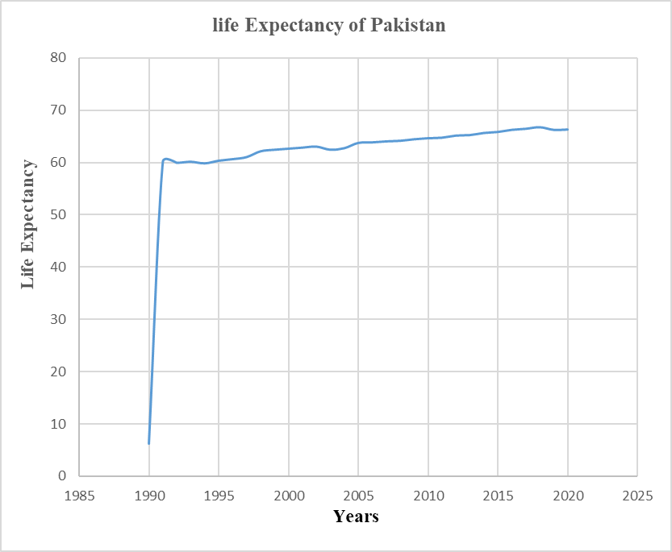

**Figure: (1) Life Expectancy of Pakistan from the year 1990- 2020.**

**Summary Table of Gross Fix Capital (Physical Capital) in Pakistan**

**Table No. 2 Gross Fix Capital Formation of Pakistan since 1990-2020**

|  |  |
| --- | --- |
| Mean | 2.631 |
| Standard Error | 1.184106468 |
| Median | 2.55 |
| Mode | 2.4 |
| Standard Deviation | 6.485618228 |
| Sample Variance | 42.06324379 |
| Kurtosis | -0.494838671 |
| Skewness | 0.22405969 |
| Range | 23.47 |
| Minimum | -7.7 |
| Maximum | 15.77 |
| Sum | 78.93 |
| Count | 30 |
| Largest (1) | 15.77 |
| Smallest (1) | -7.7 |

**Graphical Repression of Gross Fix Capital Formation in Pakistan-**

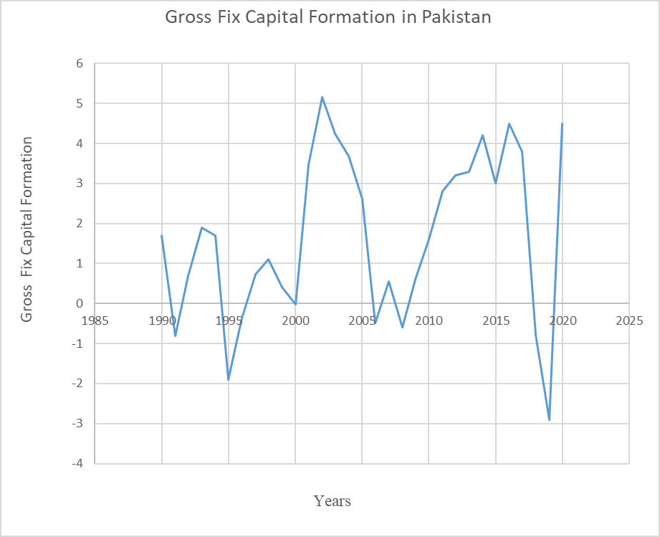

**Figure: (2) Gross Fix Capital Formation of Pakistan since 1990-2020**

**Summary Table of GDP Per Capita Growth Rate in Pakistan**

**Table No. 3 GDP Per Capita Growth Rate of Pakistan since 1990-2020**

|  |  |
| --- | --- |
| Mean | 1.662 |
| Standard Error | 0.388103375 |
| Median | 1.65 |
| Mode | 4.5 |
| Standard Deviation | 2.125729733 |
| Sample Variance | 4.518726897 |
| Kurtosis | -0.881290427 |
| Skewness | -0.203302866 |
| Range | 8.06 |
| Minimum | -2.9 |
| Maximum | 5.16 |
| Sum | 49.86 |
| Count | 30 |
| Largest (1) | 5.16 |
| Smallest (1) | -2.9 |

**Graphical Repression of GDP Per Capita Growth Rate in Pakistan**

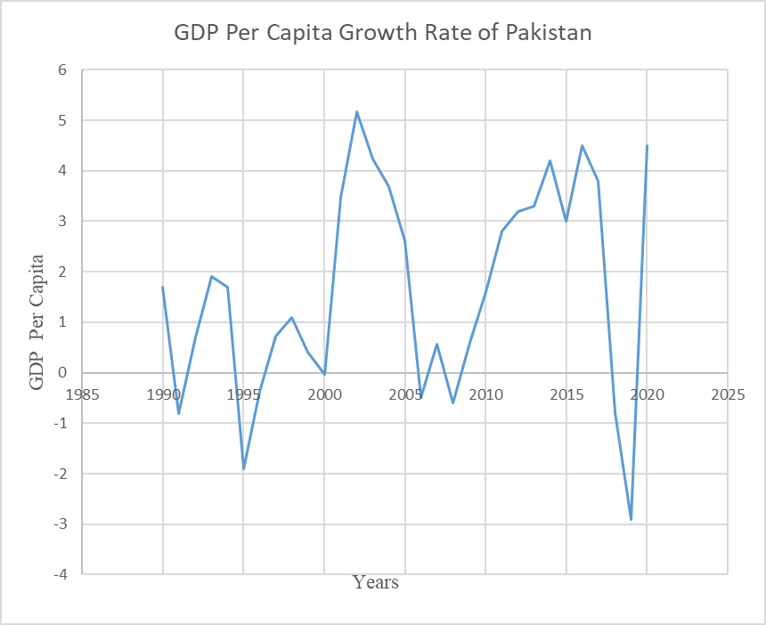

**Figure: (3) GDP Per Capita Growth Rate of Pakistan since 1990-2020**

**RESULTS AND DISCUSSION**

**Life Expectancy: Table and Graph (1)**

Results show that the Mean life expectancy is 63 years. This means the Average age of people in Pakistan is 63 years. It is depicted from the results that the maximum life expectancy is 66.7 years while the minimum is 59.8 years. The graph highlights that from 1991 to 2020 it remains the same. In 219 it slightly declines due to covid COVID-19 because of the pandemic in Pakistan.

**Gross Fix Capital Formation: Table and Graph (2)**

Results show that the average value of gross fixed capital formation is 2.6 percent. It is depicted from the results that the maximum physical capital is 15.77 percent while the minimum goes negative in some years. The graph shows that it decreased in 1991. It shows fluctuation during the last 30 years. From 1993 to 1994 it become negative due to political instability. Again in 2019, results show a negative impact due to economic crises throughout the world, which affected Pakistan.

**GDP Per Capita Growth Rate: Table and Graph (3)**

Results show that the average growth rate is 1.66 percent. It is depicted from the results that the maximum growth rate is 5.16 percent while the minimum is -2.9 percent Graph highlights that there are fluctuations in the growth rate from 1991 to 2020. In 219 it became negative (-3 percent) due to covid 19 and the growth rate increased up to 4.5 percent in 2020.

**FINDINGS**

It is found that. Life Expectancy in Pakistan is 63 years. It declined in 2019 due to covid 19.It is recommended that life expectancy has been decreased in 2019 due to inefficient budget allocation. There is a need for more budget allocation for the healthcare sector. There are persistent fluctuations in gross fixed capital formation and GDP per capita growth rate. It became negative from 1993 to 1994 due to political instability. There is a demand for time and more budget allocation for health required. Political stability is needed for economic growth and to increase gross fixed capital formation.

**CONCLUSION**

Based on the findings, it is concluded that there is low capital formation in Pakistan. Investment from other countries and governments is a requirement of time.to compete with other nations more gross fixed capital formation will lead GDP per capita growth rate. Political stability is necessary for the upsurge of economic growth and physical capital.

**REFERENCES**

Affandi, Y., Anugrah, D. F., & Bary, P. J. E. E. R. (2019). Human capital and economic growth across regions: a case study in Indonesia. *9*(3), 331-347. doi:10.1007/s40822-018-0114-4.

Aslam, A. (2020), “The hot debate of human capital and economic growth: why institutions may matter?”, *Quality and Quantity, 54*(4)1351-1362.

Carkovic, Maria, and Ross Levine. (2005). *Does foreign direct investment accelerate economic growth?* Does Foreign Direct Investment Promote Development 195: 220.

Cicea, Claudiu, and Corina Marinescu. 2021. Bibliometric analysis of foreign direct investment and economic growth relationship. A research agenda. *Journal of Business Economics and Management 22*: 445–66.

De Mello, and Luiz R., Jr. (1997). Foreign direct investment in developing countries and growth: A selective survey. *The Journal of Development Studies 34*: 1–34

Elakkad, R. M., and Asmaa, M. H. (2021). The Effect of Official Development Assistance on Domestic Savings and Economic Growth in Egypt. *International Journal of Economics and Finance, 13*: 1–33.

Granger, C. W. J. 1969. Investigating causal relations by econometric models and cross-spectral methods, *Econometrica, 37*, 428-438.

Hafeez, A., & Rahim, A. J. J. o. R. i. S. S. (2019). Human Capital and Economic Growth: Evidence from Pakistan. *7*(1), 128-135.

Islam, M.S., and Khan, S. (2019). Impact of human capital formation on economic growth: Evidence from Bangladesh. *Global Business & Economics Anthology*,191-98.

Johansen, S. (1988). Statistical analysis of cointegration vectors. *Journal of Economic Dynamics and Control*, *12*, 231-254.

Mamun, S.A.K., Rahman, M.M., and Khanam, R. (2020), “The relation between an aging population and economic growth in Bangladesh: evidence from an endogenous growth model”, *Economic Analysis and Policy, 66*, 14-25.

McArthur, John W., and Jeffrey D. Sachs. 2019. Agriculture, Aid, and Economic Growth in Africa. *The World Bank Economic Review* 33: 1–20.

Mudassar et al; (2019) Human Capital and Economic Growth Nexus: Does Corruption Matter? *Pakistan Journal of Commerce and Social Sciences* (PJCSS) pp. 409-418 <http://hdi.handle.net/> 10419/200998.

OECD. (2008). *Benchmark Definition of Foreign Direct Investment*, 4th ed. Paris: ©OECD. ISBN 978-92-64-04573-6.

OECD. (2019). *Gross Domestic Product GDP*. Available online: https://data.oecd.org/gdp/gross-domestic-product-gdp.htm (accessed on 15 September 2021).

Ogundari, K., Awokuse, T. J. E. A., & Policy. (2018). Human capital contribution to economic growth in Sub-Saharan Africa: does health status matter more than education? *58*, 131-140. doi: 10.1016/j.eap.2018.02.001.

Roodman, D. (2014). A Replication of ‘Counting Chickens When They Hatch’. *Public Finance Review, 43*: 256–81.

Roopchund, R. (2017). Understanding the contribution of human capital to the competitiveness of Mauritius. *International Journal of Competitiveness 1*(2), 119-135.

Sammar, B., & Waqas, M. (2014). Human capital formation and economic growth in Pakistan. *Journal of World Applied Sciences, 32(*4), 635-541.

Shah. A. Z; Shabbir. R and Parveen. S 2020. Does Human Capital Contribute to Achieving Economic Growth Path in Pakistan? *An Empirical Investigation, IRASD Journal of Management, 4*, pp.51-60. <https://doi.org/> 10.52131/jom.2022.0401.0061.

Singhania, Monica, and Neha Saini. 2018. Determinants of FPI in developed and developing countries. *Global Business Review 19*: 187–213.

Solow, Robert M. 1956. A contribution to the theory of economic growth. *The Quarterly Journal of Economics 70*: 65–94.

Zall_e, O. (2019), “Natural resources and economic growth in Africa: the role of institutional quality and human capital”, *Resources Policy, 62*, 616-624.

1. Corresponding Author